**TASK # 1 : Write a JavaScript function that checks whether a passed string is palindrome or not?**

**Code :**

<!DOCTYPE html>

<html>

<head>

<title></title>

<meta charset="utf-8" />

</head>

<body>

<input type="text" name="text2" required id="text2"/>

<button onclick="Palindrome(document.getElementById('text2').value)">Check</button>

<script>

function Palindrome(text2) {

var pal = "";

for (var i = text2.length-1; i >= 0; i--) {

pal += text2[i];

}

if (text2 == pal) {

alert("yes they are palindrome")

}

else {

alert("not a palindrome")

}

}

</script>

</body>

</html>

**Output:**



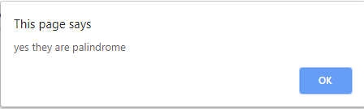

**Task # 2 : Write a JavaScript function that returns a passed string with letters in alphabetical order.**

**CODE :**

<!DOCTYPE html>

<html>

<head>

<title></title>

<meta charset="utf-8" />

</head>

<body>

<input type="text" id="text1" required name="text1" />

<button name="mybutton" onclick="mySort(document.getElementById('text1').value)">Sort</button>

<script>

function mySort(text) {

var myarray = [];

for (var i = 0; i < text.length; i++) {

myarray.push(text[i])

}

myarray.sort();

alert(myarray+text);

text = "";

for (var h = 0; h < myarray.length; h++) {

text += myarray[h];

}

alert(text);

}

</script>

</body>

</html>

**OUTPUT:**



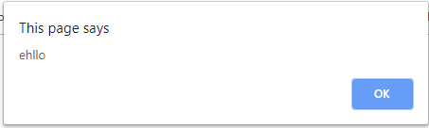

**TASK # 3 : Write a JavaScript program to implement any 5 function.**

**Code :**

<!DOCTYPE html>

<html>

<head>

<title></title>

<meta charset="utf-8" />

</head>

<body>

<button id="mybutton" onclick="myFunctionSort()">Sort</button>

<button id="mybutton" onclick="myFunctionSplice()">Splice</button>

<button id="mybutton" onclick="myFunctionSlice()">Slice</button>

<button id="mybutton" onclick="myFunctionPush()">Push</button>

<button id="mybutton" onclick="myFunctionPop()">Pop</button>

<script>

mylist = [676,135,374,843,125];

function myFunctionSort() {

newlist = mylist.sort();

document.write(newlist);

}

function myFunctionSplice() {

mylist.splice(2,0,"mango");

document.write(mylist);

}

function myFunctionSlice() {

newlist = mylist.slice(0, 3);

document.write(newlist);

}

function myFunctionPush() {

mylist.push("new element pushed");

document.write(mylist);

}

function myFunctionPop() {

mylist.pop();

document.write(mylist);

}

</script>

</body>

</html>

**OUTPUT:**

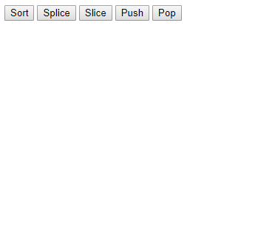

**Sort**

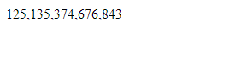

**TASK # 4 : Write a JavaScript conditional statement to find the largest of five numbers. Display**

**an alert box to show the result.**

**CODE :**

<!DOCTYPE html>

<html>

<head>

<title></title>

<meta charset="utf-8" />

</head>

<body>

<button onclick="findMax()">Findmax</button>

<script>

var mylist = [99, 44, 8, 5, 23, 1];

function findMax() {

newlist = mylist.sort()

document.writeln(newlist[newlist.length-1])

}

</script>

</body>

</html>

**Output :**

**LIST numbers = [99, 44, 8, 5, 23, 1];**



